CEBU INSTITUTE OF TECHNOLOGY
UNIVERSITY

COLLEGE OF COMPUTER STUDIES

Software Design Description
for

EvacSense

Change History Signature

Version | Description | Date
1.0 | Initial Draft | May 23, 2026
1.1 | Version 1.1 | May 25, 2026
1.2 | Version 1.2 | May 26, 2026
1.3 | Version 1.3 | May 29, 2026

Preface

___

Table of Contents

1. Introduction 6
1.1. Purpose 6
1.2. Scope 6
1.3. Definitions and Acronyms 6
1.4. References 6
2. Architectural Design 7
3. Detailed Design 8
Module 1 8
Module 2 12
Module 3 22
Module 4 33
Module 5 37

Introduction

Purpose
This Software Design Description (SDD) delineates the architectural and detailed design frameworks for EvacSense, an integrated web and mobile platform engineered to facilitate earthquake drill attendance tracking, navigational guidance, and real-time reporting within Philippine educational facilities. This document serves as a technical specification for developers, architects, and relevant stakeholders, providing the necessary design blueprints for the implementation of the system's five core modules.

Scope
This SDD covers the design of the complete EvacSense system including:
- Module 1: User Authentication System
- Module 2: Classroom Presence Recording
- Module 3: Shortest-Path Evacuation Navigation
- Module 4: Evacuation Area Attendance and Authentication
- Module 5: Post-Drill Monitoring and Real-Time Reporting
The document includes architectural design, detailed component design for each module, class diagrams, sequence diagrams, database schemas, and API specifications.

Definitions and Acronyms

RSSI -Received Signal Strength Indicator; Wi-Fi signal measurement
JWT - JSON Web Token; stateless authentication mechanism
API - Application Programming Interface
UI/UX - User Interface / User Experience
ERD - Entity Relationship Diagram; database schema visualization
2FA - Two-Factor Authentication (Student ID + Face Recognition)
MVP - Minimum Viable Product

References
  - EvacSense Project Proposal (May 2026)
  - Software Requirements Specification (SRS) v1.0
  - IEEE Std 1016-2009 — Standard for Information and Description of Software Design
  - React Native Documentation: https://reactnative.dev/
  - Node.js/Express Documentation: https://nodejs.org/
  - PostgreSQL Documentation: https://www.postgresql.org/docs/

Architectural Design
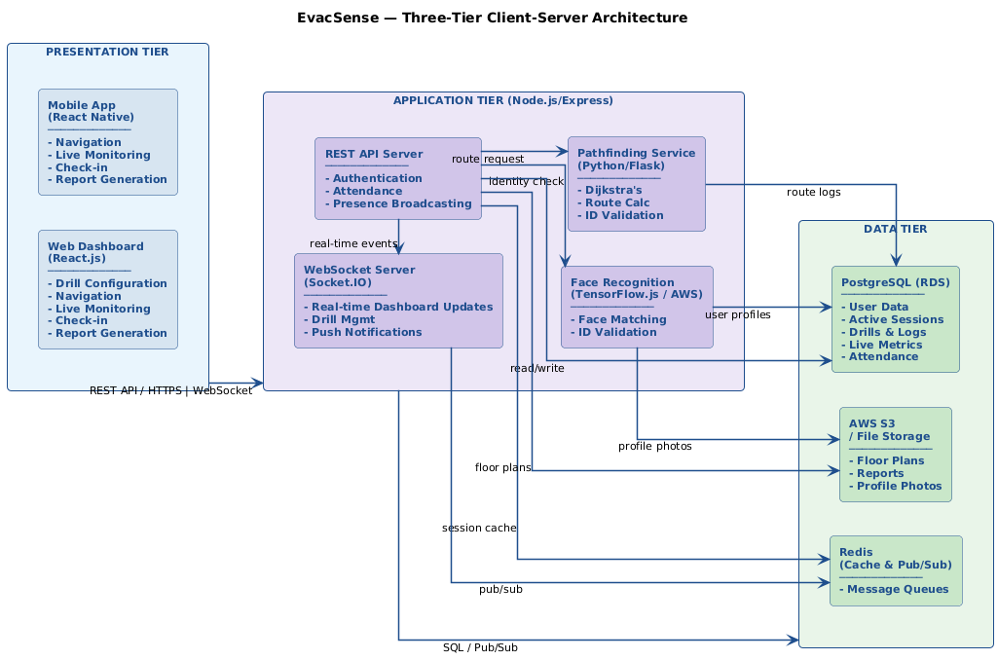

Detailed Design

Module 1 - User Authentication System

1.1 User Login and Role-Based Access
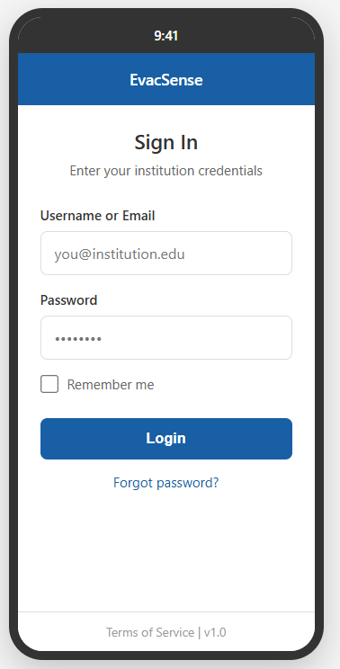
- Front-end component(s)
Component Name | Description and Purpose | Type/Format
LoginScreen | Entry point for all users; displays email/password fields and a "Register" option; routes to role-appropriate dashboard post-login | React Native Screen
LoginForm | Controlled form with validation for institutional email and password; shows inline errors for invalid credentials and "Account Pending Approval" state | React Native Component
RegisterScreen | Branching registration entry; displays role selector (Student, Teacher, Coordinator) and routes to the appropriate registration form | React Native Screen
StudentRegistrationForm | Collects full name, institutional email, student ID, and password; triggers device ID capture on submit; shows duplicate and validation errors | React Native Component
TeacherCoordinatorRegistrationForm | Collects full name, institutional email, employee ID, role selection, and password; submits for admin approval; displays "Pending Approval" confirmation | React Native Component
RegistrationRequestsPanel | Web dashboard view for Admin; lists all Pending Approval registration requests with user details; provides Approve and Reject actions | React.js Page Component
RejectionReasonModal | Modal that appears when Admin clicks Reject; requires a rejection reason before the submission can be confirmed | React.js Component
RoleRedirect | Post-login routing logic that reads the JWT role claim and navigates Admin/Coordinator to the Web Dashboard, Student/Teacher to the Mobile App Dashboard | React Native Navigation Hook
WebLoginPage | Web dashboard login equivalent for Coordinators and Admins; email/password fields with the same validation logic | React.js Page Component
AccountRecoveryScreen | Prompts user for institutional email; submits recovery request and displays success or failure feedback | React Native Screen

- Back-end component(s)
Component Name | Description and Purpose | Type/Format
AuthController | Handles POST /api/auth/login; validates email and password credentials directly against the database; issues JWT on success; returns role and account status; rejects Pending Approval accounts with a dedicated error code | Node.js/Express Controller
MicrosoftTokenValidator | Captures and records the mobile device's unique identifier at registration time; returns an error if capture fails so registration is blocked until retry succeeds | Node.js Service Module
UserModel | ORM model for users table; fields: id, email, password_hash, role, employee_id, student_id, device_id, status (Active / Pending Approval / Rejected), created_at | Sequelize Model
DeviceIDCaptureService | Captures and records the mobile device's unique identifier at registration time; returns an error if capture fails so registration is blocked until retry succeeds | Node.js Service Module
StudentRegistrationController | Handles POST /api/auth/register/student; validates all fields, checks for duplicate email/student ID, captures device ID, creates account with role = Student and status = Active | Node.js/Express Controller
RegistrationApprovalController | Handles POST /api/auth/approve/:userId and POST /api/auth/reject/:userId; sets status = Active on approval or status = Rejected on rejection; requires a rejection reason on reject; sends notification to user in both cases | Node.js/Express Controller
RegistrationNotificationService | Sends push or email notification to Admin when a new Teacher/Coordinator registration request arrives; sends approval or rejection notification to the registrant upon Admin decision | Node.js Service Module
AccountRecoveryController | Handles POST /api/auth/recover; verifies email against registered accounts; dispatches a recovery email; returns a generic success response regardless of match to prevent account enumeration | Node.js/Express Controller
JWTService | Signs and verifies JSON Web Tokens using Microsoft Entra ID-issued identity as the claim source; sets 1-hour inactivity expiry; invalidates all sessions on logout | Node.js Service Module
RBACMiddleware | Express middleware that reads the JWT role claim and enforces route-level permissions; Admin and Coordinator routes are inaccessible to Student and Teacher roles | Node.js Middleware
SessionLogger | Logs all authentication events — login, logout, failed attempts, token rejections — with user ID, IP address, and timestamp for audit compliance under RA 10173 | Node.js Service Module

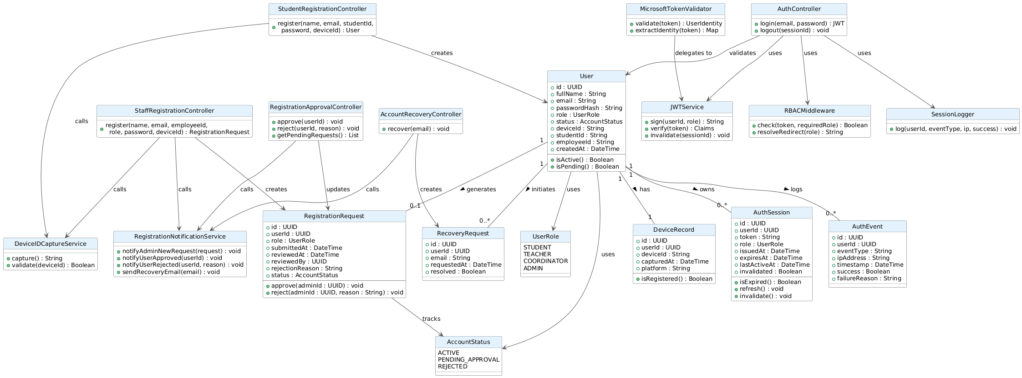.

.
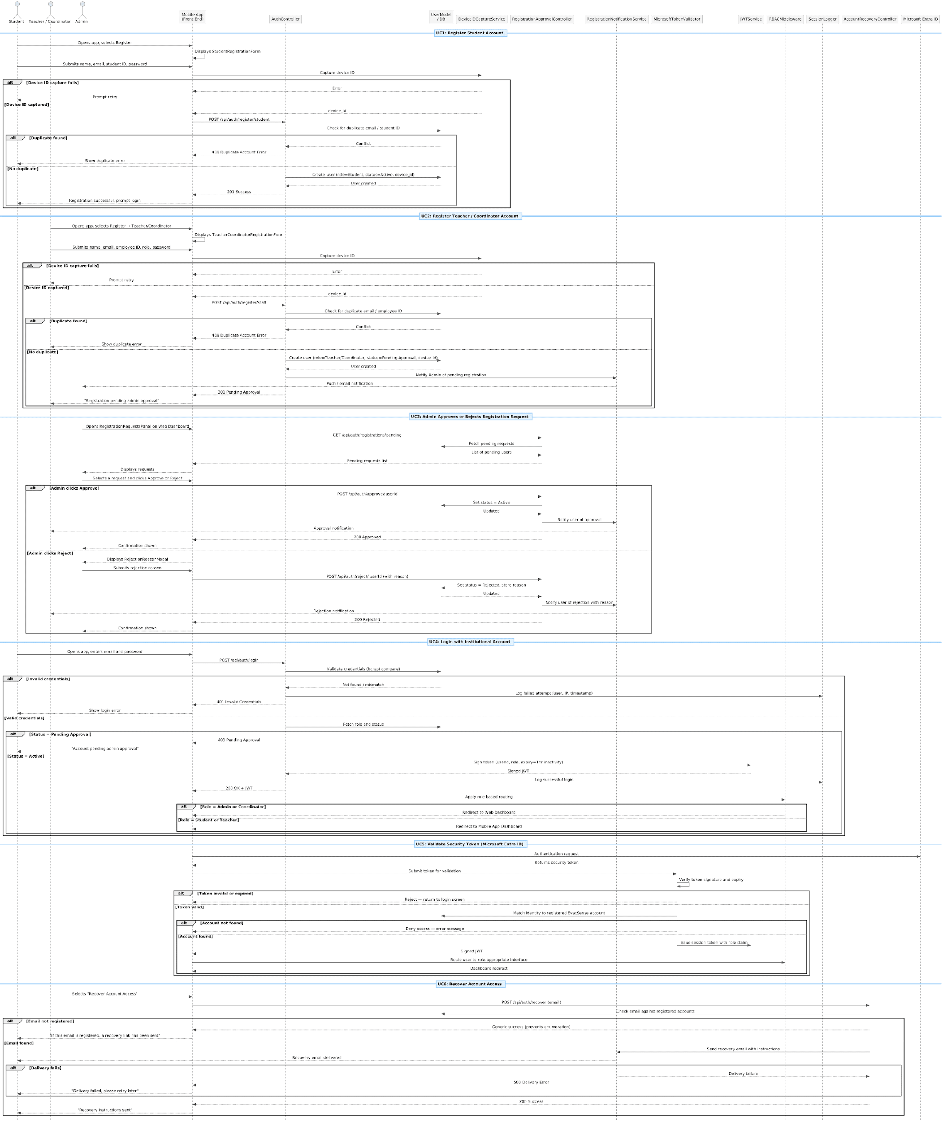

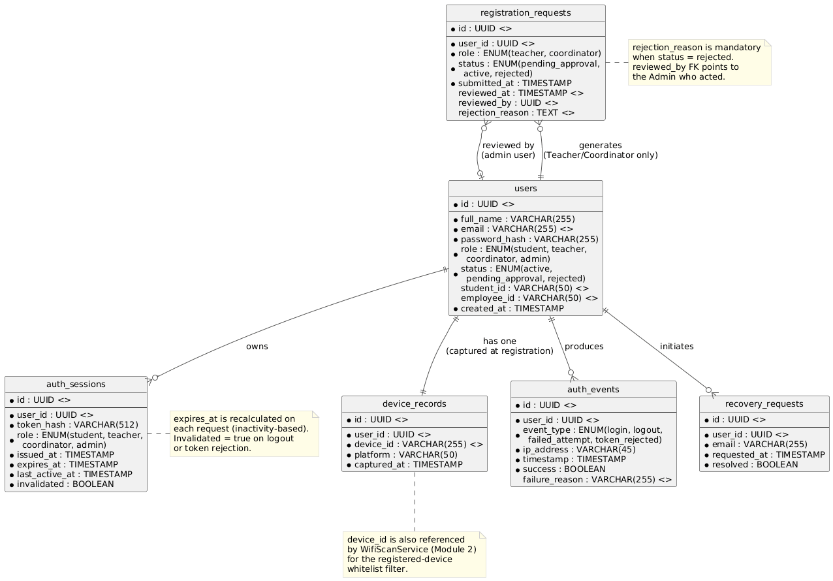

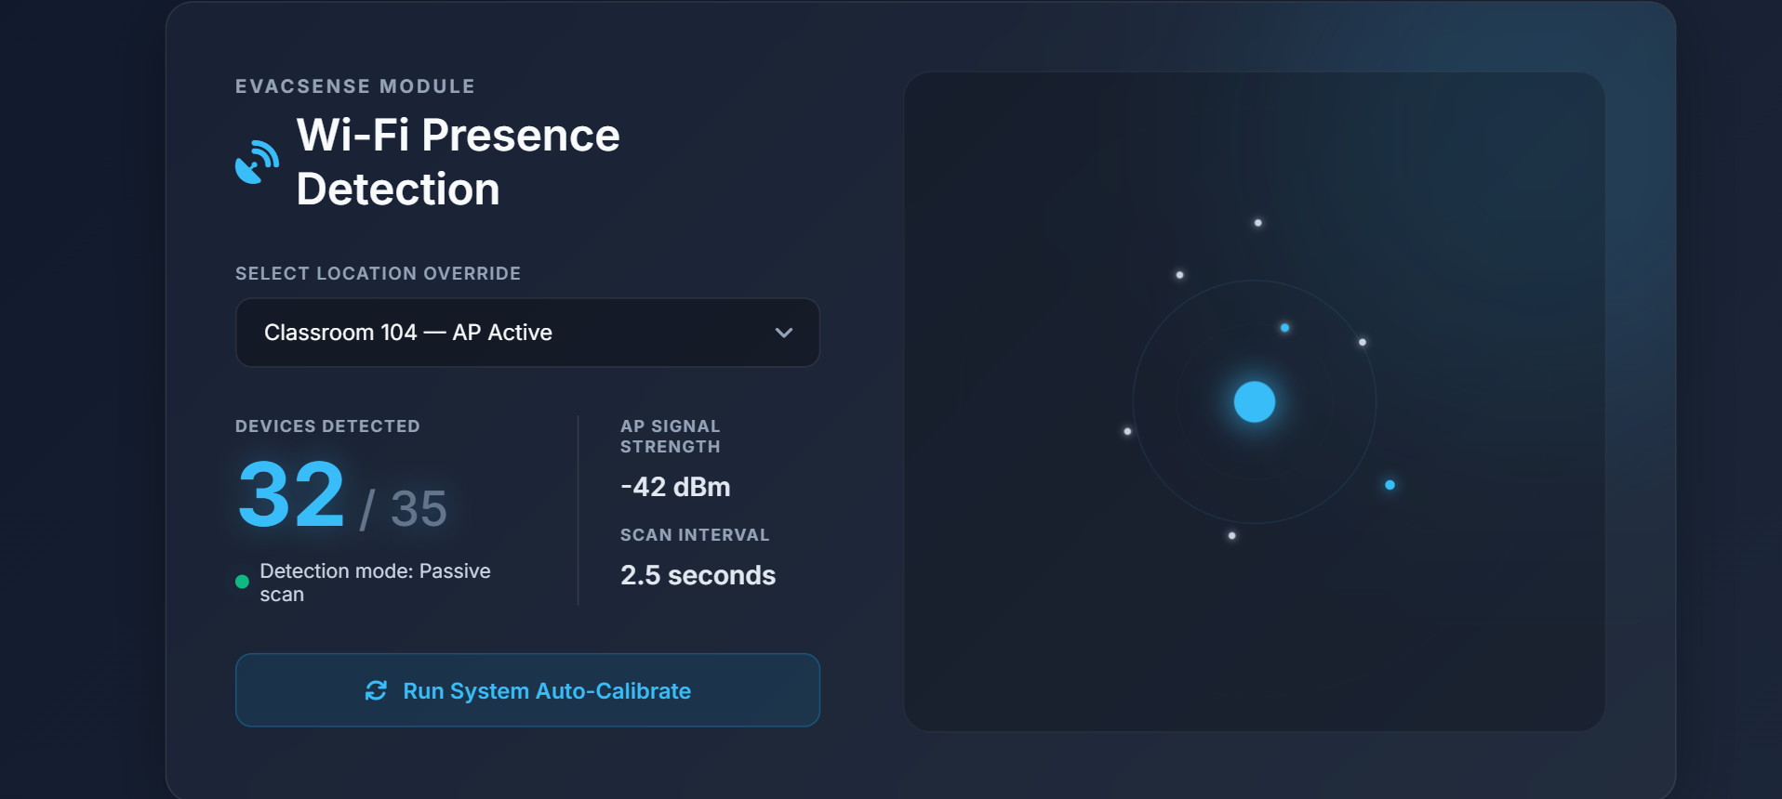

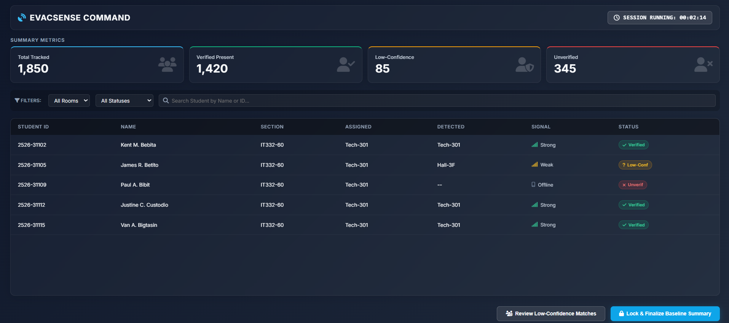

Module 2 - Classroom Presence Recording

2.1 Record Pre-Drill Classroom Occupancy

- Front-end component(s)

Component Name | Description and Purpose | Type/Format
PresenceScreen | Displays current detection status and room assignment to the student after drill is activated | React Native Screen
WifiDetectionScreen | Polls backend for Wi-Fi scan status; shows radar animation during active RSSI scan | React Native Screen
LocationConfirmCard | Displays confirmed room name and floor after successful Wi-Fi detection | React Native Component
ManualRoomEntry | Fallback form allowing the student to manually select their classroom from a dropdown if Wi-Fi detection fails | React Native Component
OccupancyDashboard | Web table showing per-room headcount broken down by detection method and status; visible to Safety Officer | React.js Component
AmbiguousDetectionCard | Shown when a weak-signal (ambiguous) detection occurs; displays the tentative classroom assignment, a "Low-confidence detection" icon, and a note that marshal confirmation is required at check-in | React Native Component
DrillActivationButton | Web table showing per-room headcount broken down by three detection statuses: Verified, Ambiguous (low-confidence), and Location-Unverified; displays the "Low-confidence detection" icon next to ambiguous entries | React.js Component

- Back-end component(s)

Component Name | Description and Purpose | Type/Format
PresenceController | Receives room assignment submissions (both auto and manual); logs occupancy records to DB | Node.js Controller
WifiScanService | Reads RSSI data from campus access points; filters signals exclusively from device IDs registered in device_records (security NFR — unregistered devices are ignored); maps signal strength to room zones; implements automatic retry logic for intermittent connectivity | Node.js Service Module
RSSITriangulator | Applies weighted-centroid algorithm to multi-AP RSSI readings; returns a result object containing the room match AND a confidence classification: VERIFIED (above threshold), AMBIGUOUS (weak but active signal from adjacent room/hallway), or UNREACHABLE (device not detected) | Node.js Service Module
ClassroomMatcher | Maps triangulated position to room_id using floor plan graph data stored in the database | Node.js Service Module
OccupancyModel | ORM model for classroom_occupancy table; fields: id, drill_id, user_id, room_id, detection_confidence (VERIFIED / AMBIGUOUS / UNVERIFIED), rssi_value, navigation_origin_set, marshal_confirmed, detected_at | Sequelize Model
PresenceBroadcaster | Publishes occupancy updates (including confidence levels) to Redis Pub/Sub for real-time dashboard sync; must deliver the classroom presence list to the Safety Officer dashboard within 5 seconds of drill activation | Node.js Service Module
DrillSessionController | Handles POST /api/drill/activate; validates Safety Officer role; sets drill session to Active in the database; triggers WifiScanService to begin the classroom detection sweep across all registered devices | Node.js/Express Controller
UnverifiedFlagService | After the scan sweep completes, cross-references all registered students against the occupancy results; marks any student with no detection record as UNVERIFIED and sets navigation_origin_set = false; these students are surfaced for manual follow-up in Module 4 | Node.js Service Module

- Object-Oriented Components
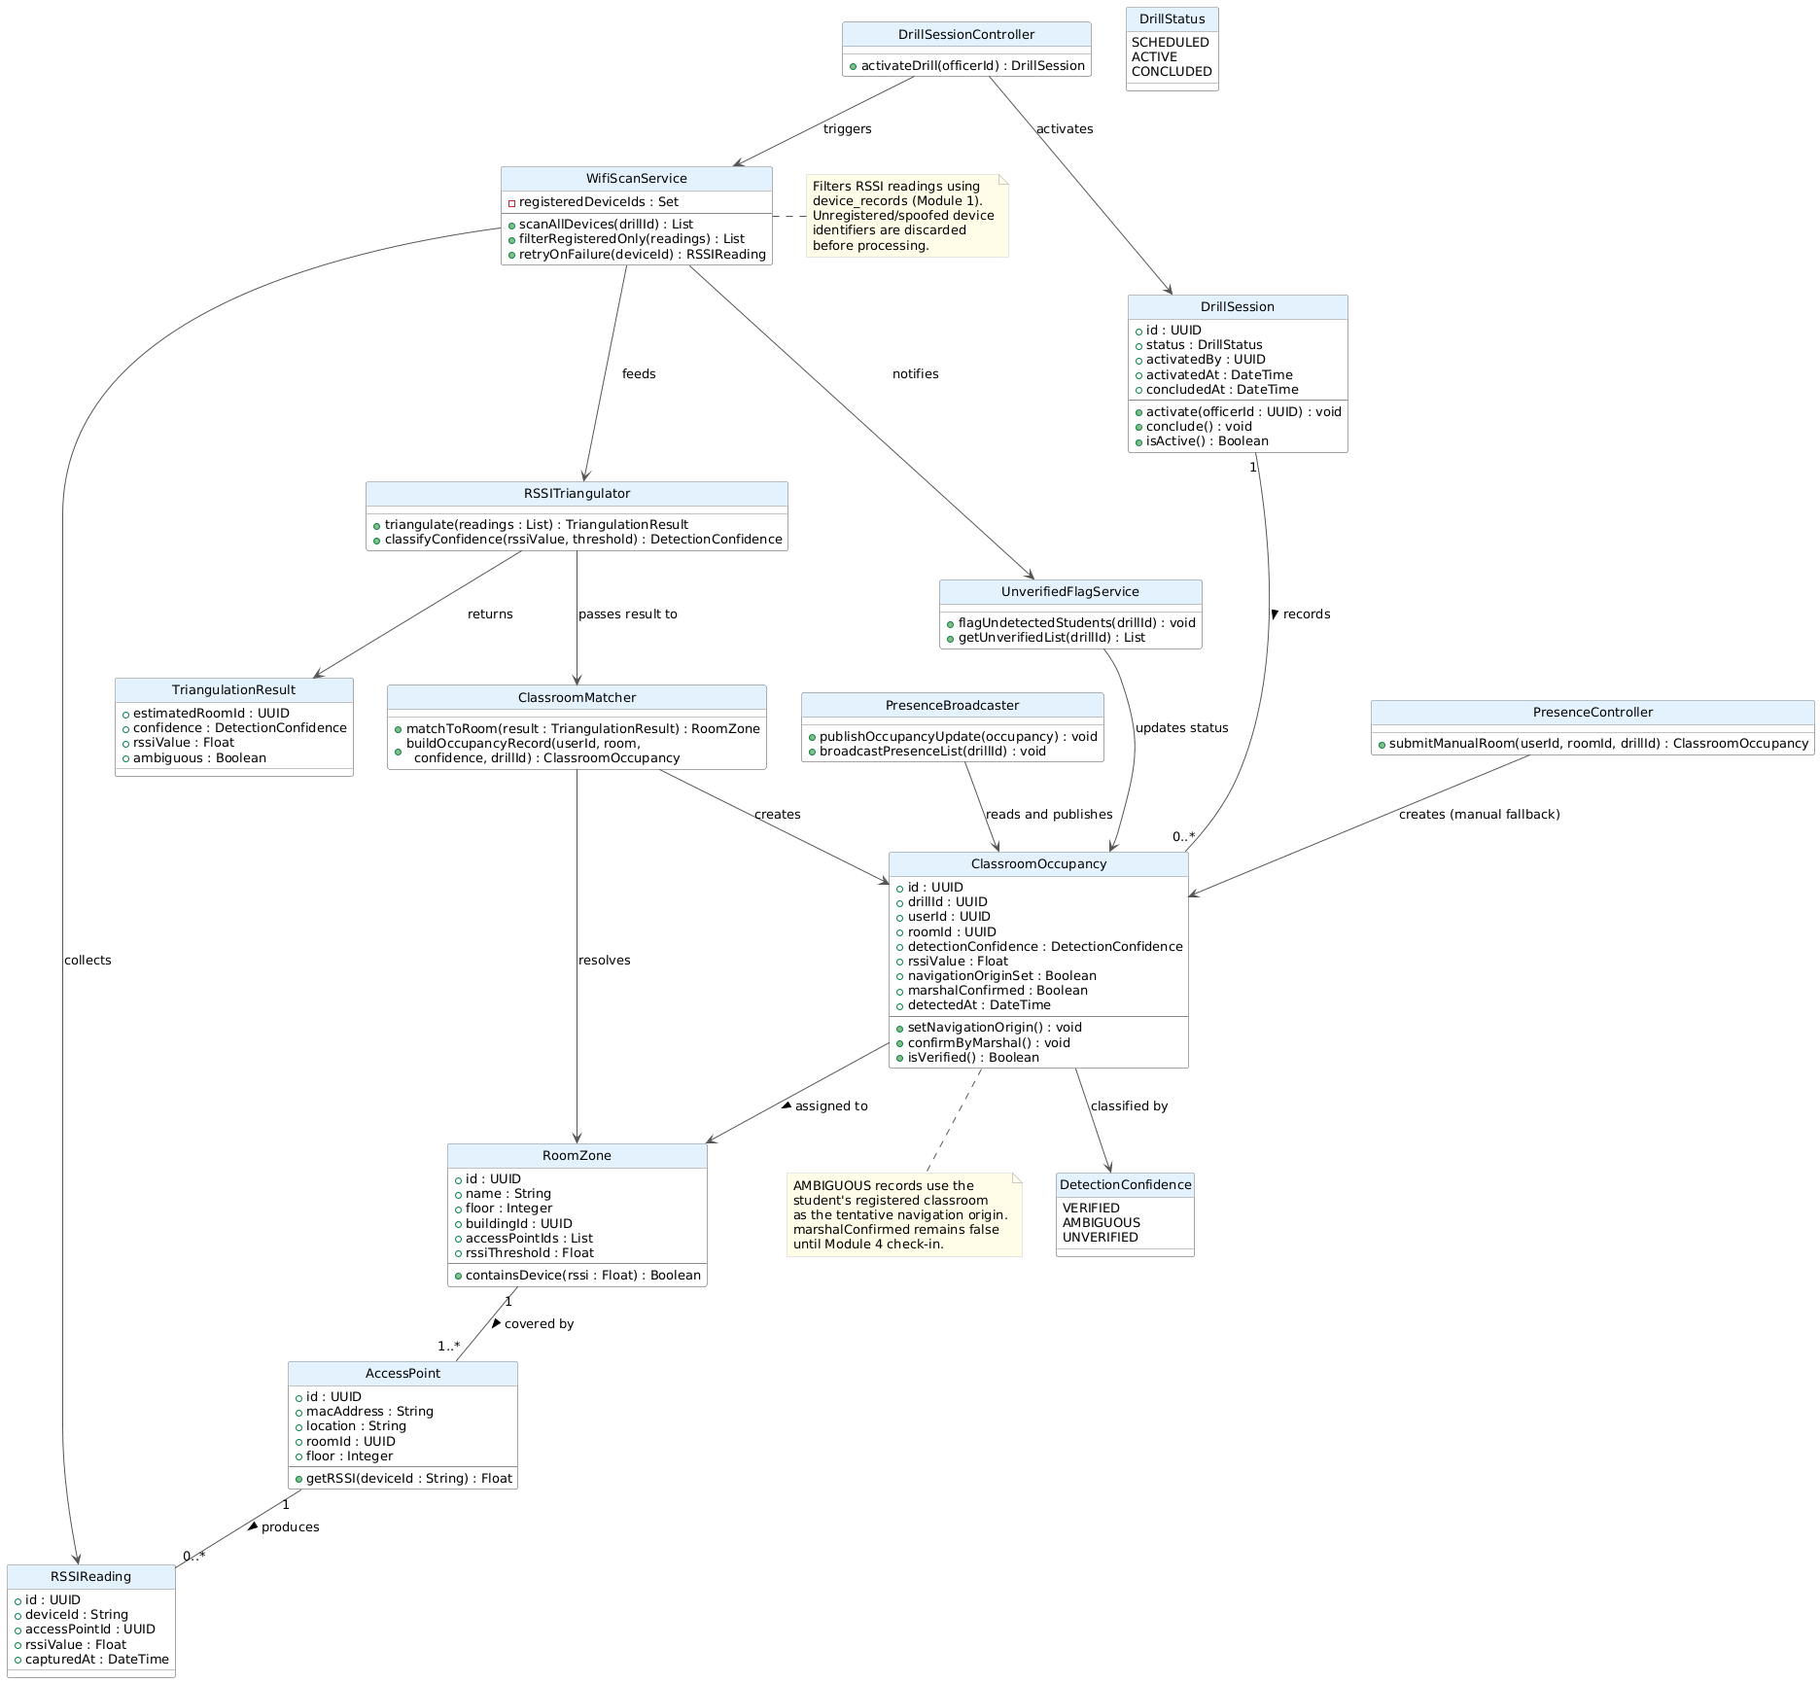

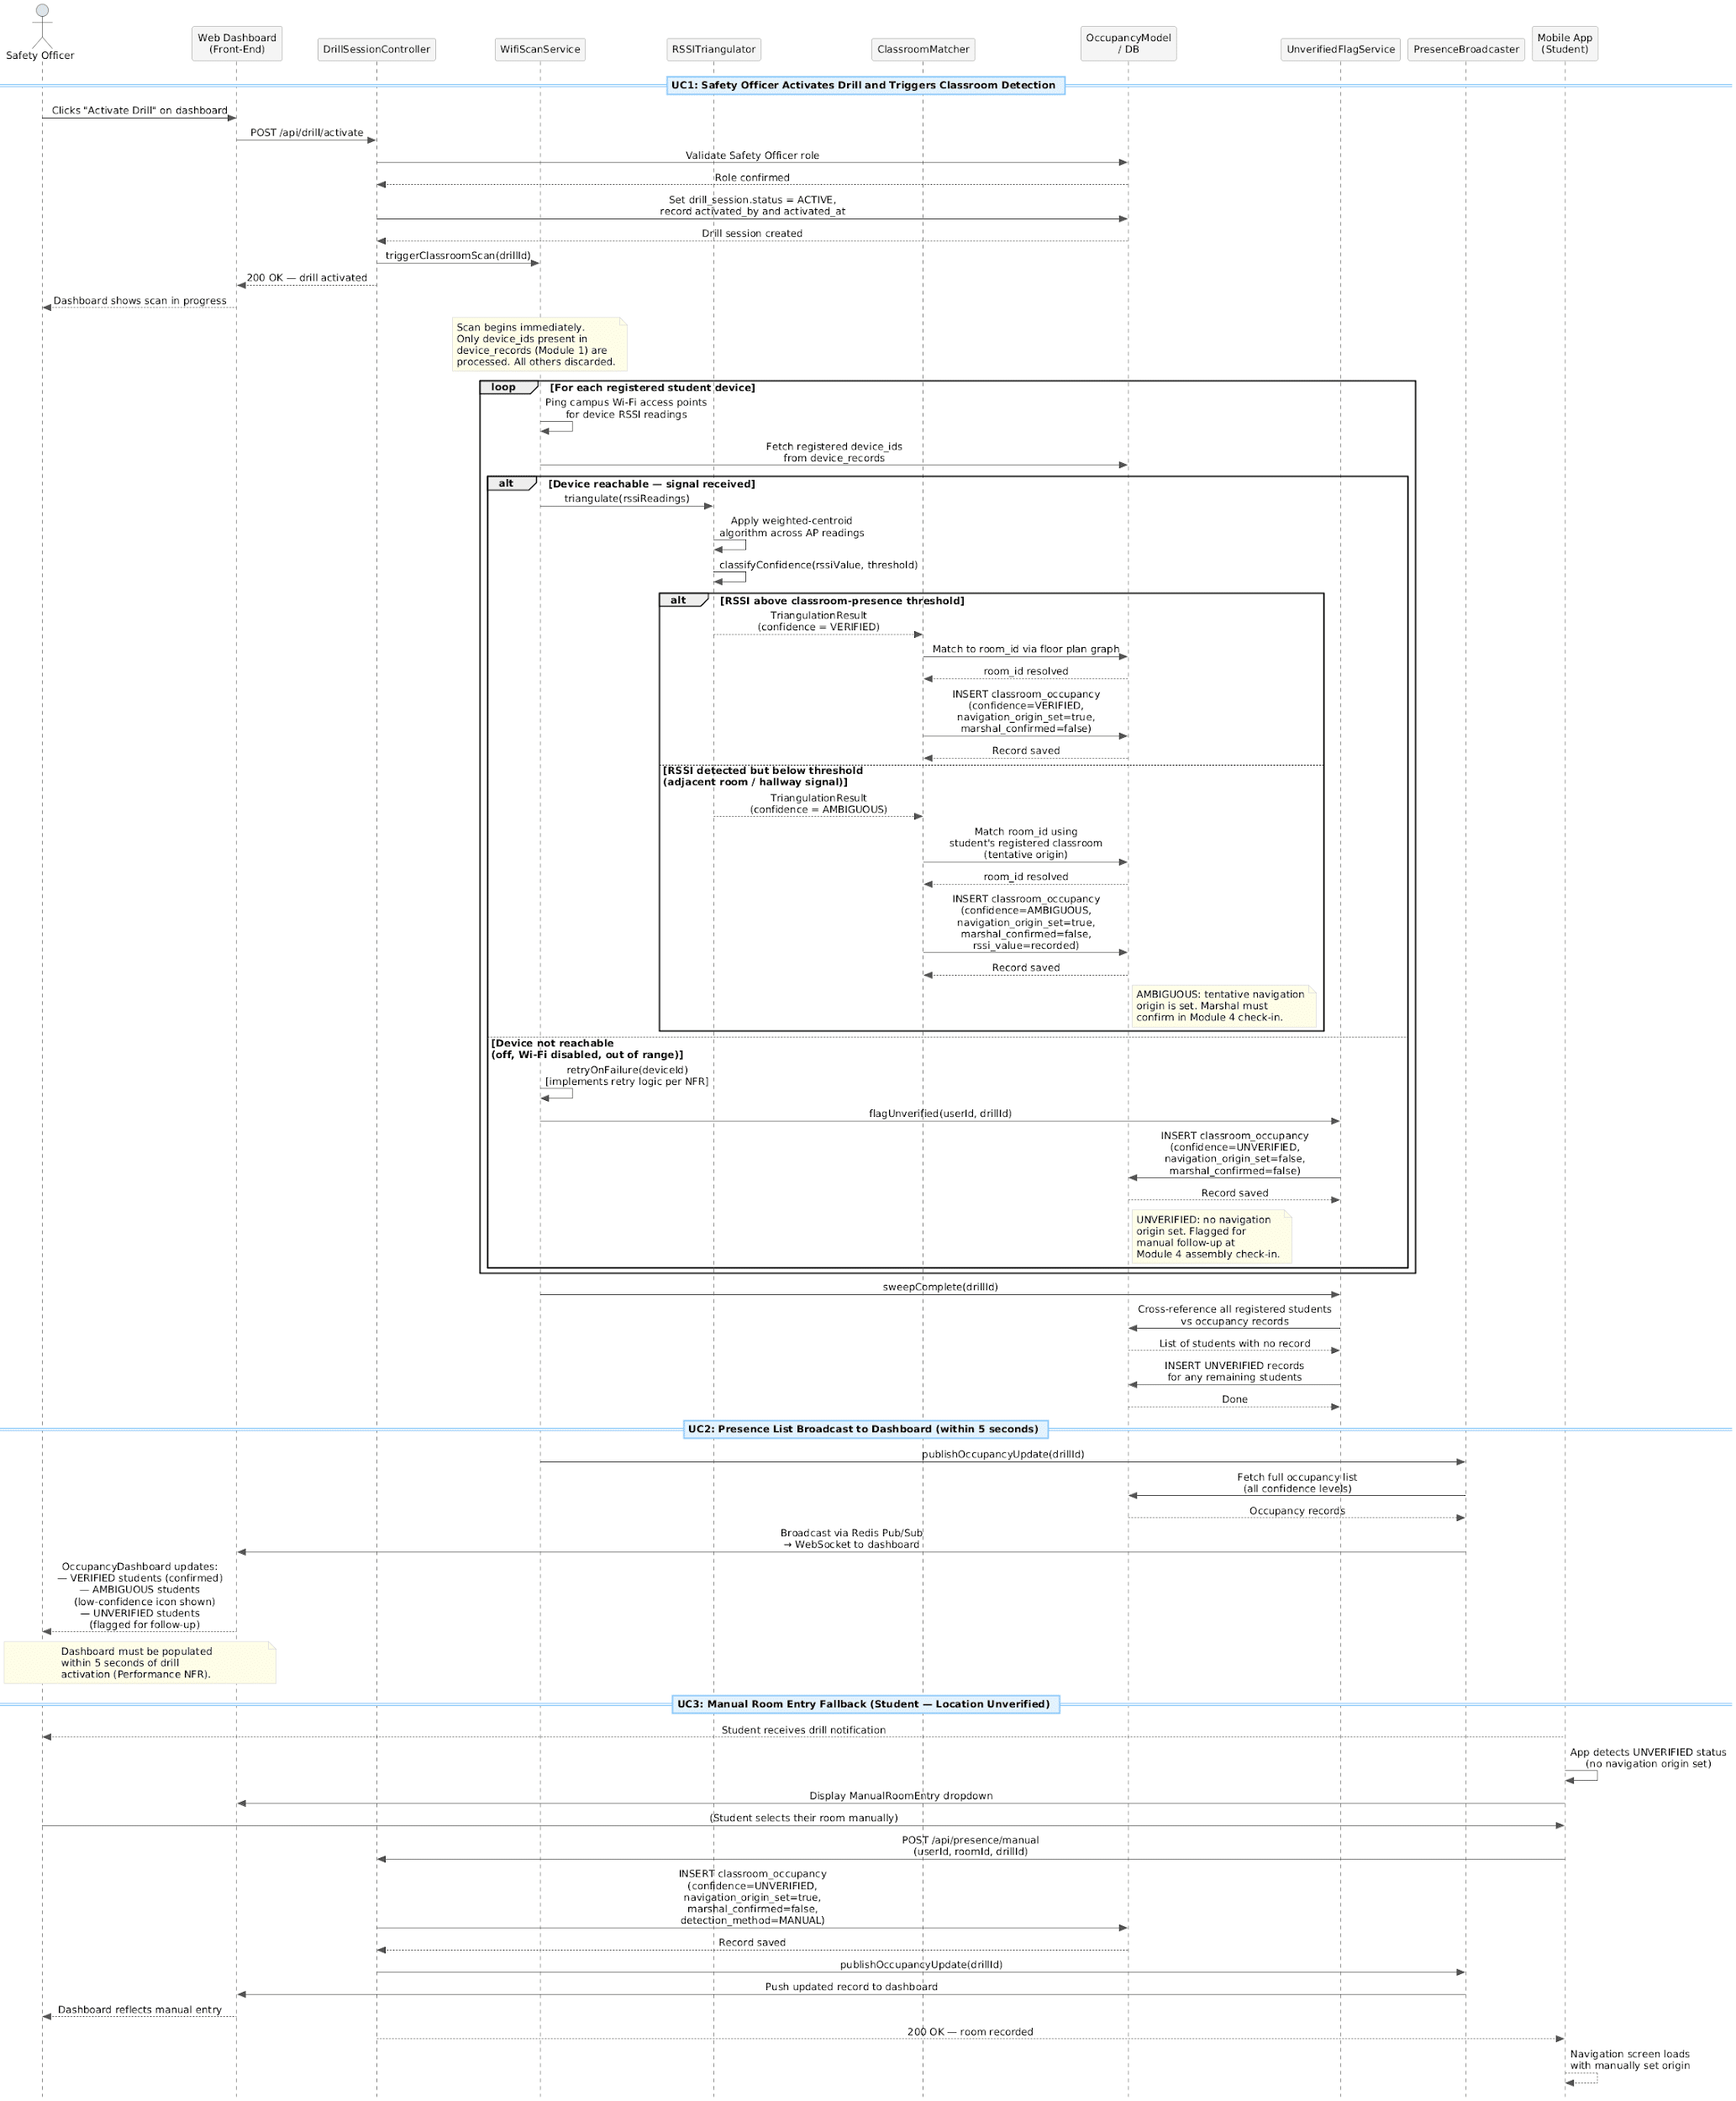
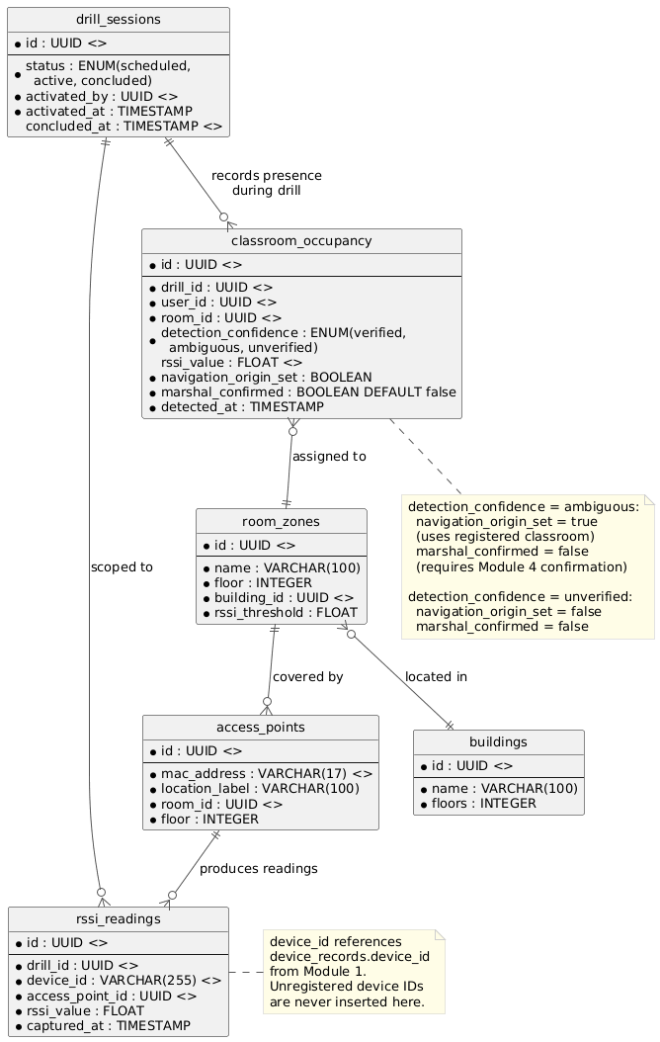

Module 3 - Shortest-Path Evacuation Navigation

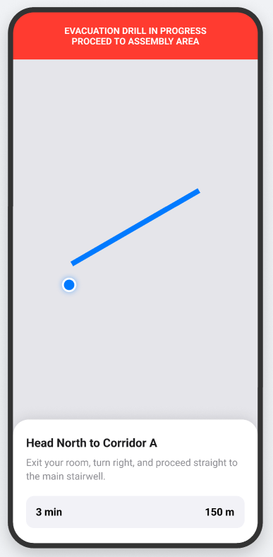
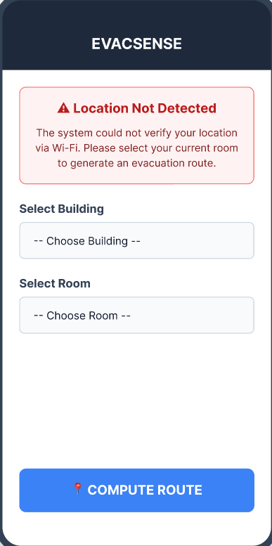
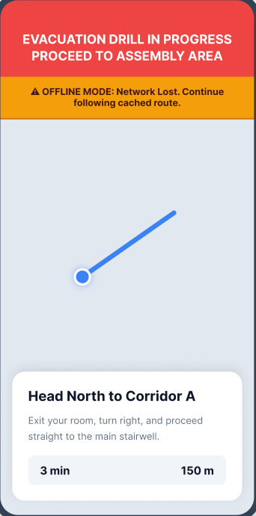
Display Evacuation Route

Front-end component(s)
Component Name | Description and Purpose | Type/Format
NavigationScreen | Main screen showing floor plan map and turn-by-turn directions | React Native Screen
FloorPlanRenderer | Renders SVG-based floor plan with the computed route path overlaid | React Native SVG Component
DirectionCard | Bottom card showing current instruction, ETA, and distance | React Native Component
RouteCache | Stores the last successfully received route payload in local device storage immediately upon delivery; serves the cached static route to FloorPlanRenderer and DirectionCard when the network connection drops, ensuring navigation remains visible offline | React Native Local Storage Module
OfflineStatusBanner | Displays a persistent banner notifying the student that real-time updates are paused due to a lost network connection; auto-dismisses when connectivity is restored and live updates resume | React Native Component
ManualOriginPicker | Dropdown presented when Wi-Fi RSSI cannot detect the student's location at navigation start (weak signal fallback specific to Module 3); allows the student to manually select their current room before the route is computed | React Native Component
RouteUpdateBanner | Animated yellow banner that appears when a dynamically recomputed route is pushed via WebSocket due to a blocked path; prompts the student to follow the new route | React Native Component
DynamicFloorPlan | Re-renders the route overlay when a new path is received; draws the previously active path in red to indicate the blockage and the new path in the standard route color | React Native SVG Component
DefaultExitAlert | Alert dialog shown when no valid route is found due to a configuration error; directs the student to the nearest pre-configured default safe exit | React Native Component
RouteConfigPage | Web dashboard page where the Drill Coordinator maps rooms, corridors, exits, and staircases onto the interactive floor plan to configure valid evacuation pathways before a drill | React.js Page Component
FloorPlanEditor | Interactive canvas within RouteConfigPage; allows the Coordinator to select nodes (rooms, corridors, exits, staircases) and connect them with edges to define the evacuation graph; visualizes connectivity errors flagged by the validator | React.js Component
RouteConflictPanel | Shown when RouteValidationService detects duplicate, dead-end, or conflicting routes during save; lists the specific conflicts and highlights the affected nodes on the floor plan for the Coordinator to resolve | React.js Component

- Back-end component(s)
Component Name | Description and Purpose | Type/Format
PathfindingService | Python/Flask service; receives start node and destination; runs Dijkstra's on floor plan graph | Python Flask API
GraphLoader | Loads the campus floor plan graph (nodes = rooms/corridors/exits/staircases, edges = passageways with distance weights) from PostgreSQL into memory for pathfinding; reloads when the Coordinator saves a new configuration | Python Module
RouteSerializer | Converts the computed path (list of node IDs) into a structured turn-by-turn instruction set and caches the full route payload for delivery to the mobile client | Python Module
RouteConfigController | Handles POST /api/nav/config; receives the floor plan graph payload from the Coordinator; calls RouteValidationService before persisting; returns conflict details if validation fails; confirms successful save | Node.js/Express Controller
RouteValidationService | Validates the submitted evacuation graph for dead ends, disconnected nodes, duplicate edges, and unreachable assembly areas before the configuration is saved; returns a structured list of conflicts if any are found | Node.js Service Module
NavigationController | Handles POST /api/nav/route; receives the student's origin node (from Module 2 occupancy record or manual selection) and assembly area destination; calls PathfindingService; returns the serialized route payload; logs the navigation origin and route to navigation_logs | Node.js/Express Controller
BlockageController | Handles POST /api/nav/block from the Coordinator dashboard; marks the specified edge as blocked in the database; triggers RouteRecomputeService | Node.js Controller
RouteSocketBroadcaster | Pushes updated route payloads to affected students via Socket.IO room channels; also broadcasts the OfflineStatusBanner dismissal signal when a reconnected student's cached route is confirmed still valid | Node.js/Socket.IO Module
NavigationLogModel | ORM model for navigation_logs table; fields: id, drill_id, user_id, origin_node_id, destination_node_id, route_payload, origin_source (MODULE2_VERIFIED / MODULE2_AMBIGUOUS / MANUAL), computed_at, delivered_at | Sequelize Model
GraphModel | ORM model for evacuation_graph_nodes and evacuation_graph_edges tables; nodes carry type (ROOM, CORRIDOR, STAIRCASE, EXIT, ASSEMBLY_AREA) and floor; edges carry distance weight and a blocked flag | Sequelize Model

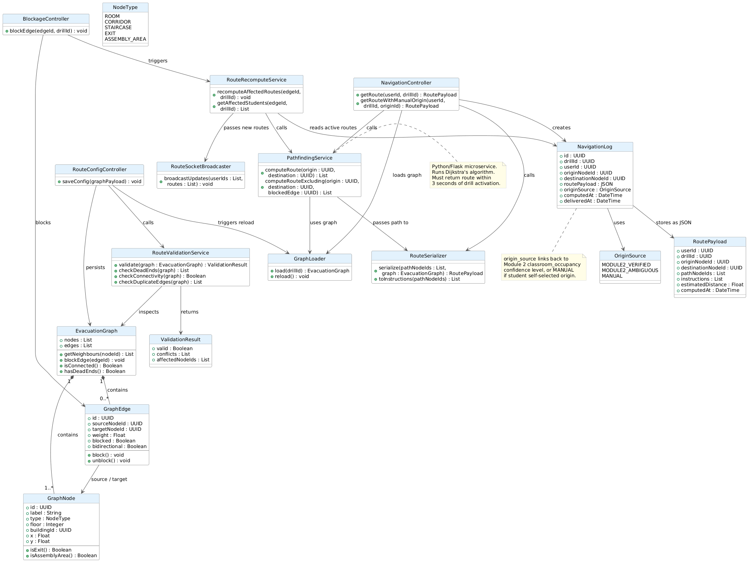
- Object-Oriented Components

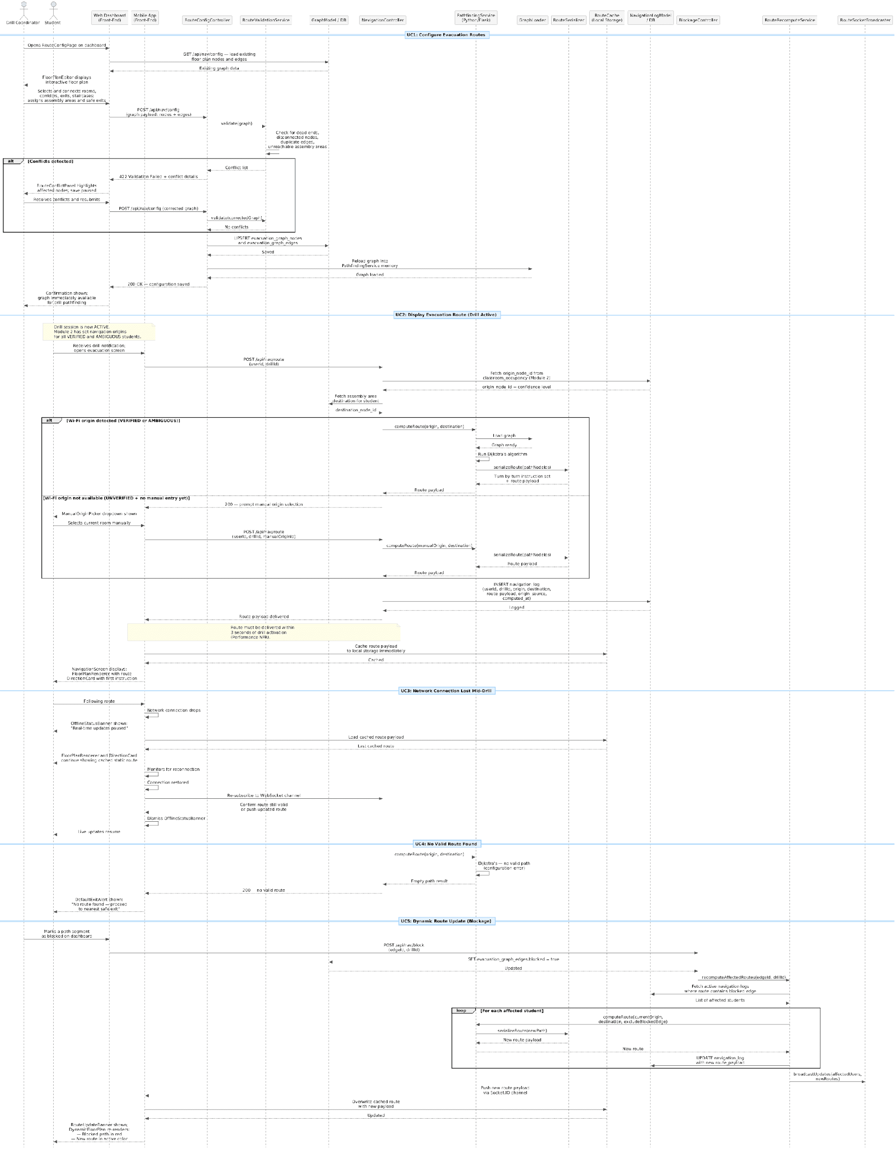
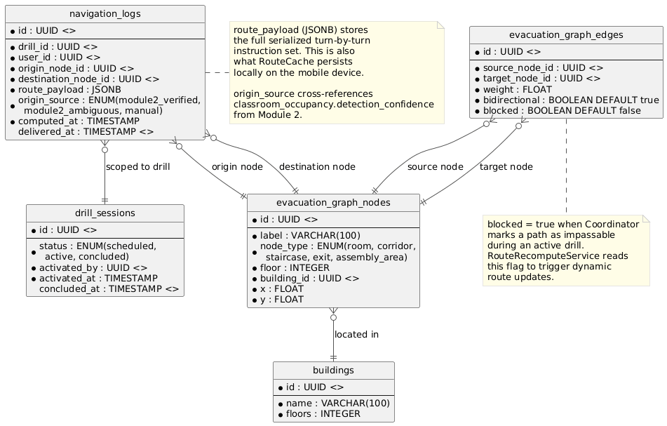
- Data Design

Module 4 - Evacuation Area Attendance and Authentication

4.1 Evacuee Arrival Confirmation
- 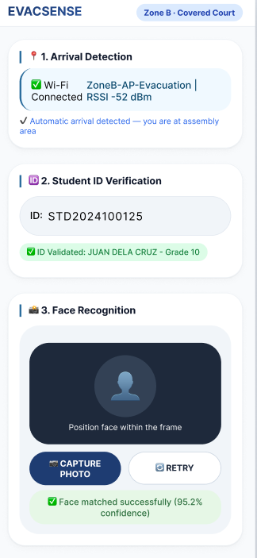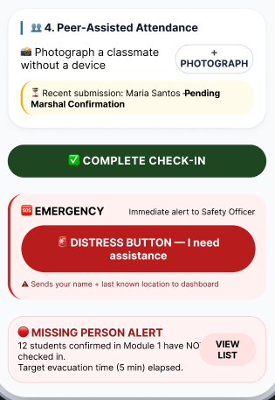
- Front-end component(s)
Component Name | Description and Purpose | Type/Format
ArrivalDetectionCard | Displays Wi-Fi arrival status; shows AP name, RSSI value, and auto-detection confirmation | React Native Component
ManualArrivalButton | Shown when Wi-Fi auto-detection fails; allows the student to manually tap "I Have Arrived" to force-trigger the Student ID input step and bypass automatic detection | React Native Component
StudentIDVerifier | Displays validated student ID and name after database lookup | React Native Component
FaceRecognitionCapture | Opens caOpens camera viewfinder for live photo capture; handles up to 3 retry attempts; displays confidence score; flags for manual marshal verification after 3 consecutive failures; confidence threshold updated to 85% (was 95%)mera viewfinder; handles capture, retry (max 3 attempts), and displays confidence score | React Native Component
PeerAttendancePanel | Companion flow: allows a Companion to input a classmate's Student ID, validate it, then trigger FaceRecognitionCapture for biometric verification; on success logs attendance as "Present (Peer-Assisted)"; displays "ID Not Found" error on invalid ID | React Native Component
LocalArrivalQueue | Queues the student's arrival timestamp and check-in payload locally when the network drops at the moment of arrival; displays an "Offline — syncing when reconnected" indicator; auto-syncs to backend upon connection restoration | React Native Local Storage Module
CompleteCheckInButton | Finalizes the check-in process and submits all verified data to the backend | React Native Component
DistressButton | Sends an immediate distress alert with the student's ID, last known location, and timestamp to the Safety Officer dashboard; if offline, caches the alert locally and aggressively retransmits in the background once connection is restored | React Native Component
MissingPersonAlert | Displays a banner showing how many students have not checked in past the target evacuation time | React Native Component

- Back-end component(s)
Component Name | Description and Purpose | Type/Format
ArrivalDetectionController | Detects student arrival at assembly area Wi-Fi zone; POST /api/checkin/detect | Node.js Controller
StudentIDValidator | Queries the database to validate the student ID and check enrollment status and active flag | Node.js Service Module
FaceRecognitionService | Calls TensorFlow.js or AWS Rekognition; requires a confidence score of at least 85% (updated from 95%) for an automatic match; prompts retry up to 3 attempts; flags the student for manual marshal verification after 3 consecutive failures; used by both direct arrival and peer-assist flows via <> | Node.js Service Module
PeerPhotoProcessor | Handles POST /api/checkin/peer; receives Companion's submitted Student ID and photo; validates the ID via StudentIDValidator; calls FaceRecognitionService; on verification success logs attendance as "Present (Peer-Assisted)"; on ID not found returns error to Companion | Node.js Service Module
AttendanceLogger | Logs the final arrival record to drill_attendance with: timestamp, check-in method (WIFI_AUTO / MANUAL_ARRIVAL / PEER_ASSISTED), face recognition confidence score, zone, verified status, and marshal_required flag; must persist to DB within 2 seconds per Performance NFR | Node.js Service Module
OfflineArrivalSyncService | Handles POST /api/checkin/sync; receives queued arrival payloads from LocalArrivalQueue when the student reconnects; validates timestamp integrity and deduplicates against existing records before writing to drill_attendance | Node.js Service Module
DistressAlertBroadcaster | Handles POST /api/alert/distress; immediately logs the distress signal (student ID, last known location, timestamp) to distress_alerts; publishes via Redis Pub/Sub to SafetyOfficerDashboardSocket; also accepts offline-cached alert payloads transmitted by LocalArrivalQueue on reconnection | Node.js Service Module
SafetyOfficerDashboardSocket | WebSocket channel dedicated to Safety Officer; receives distress alerts and missing person flags in real time | Node.js/Socket.IO Module
AttendanceModel | ORM model for drill_attendance table; fields: id, drill_id, user_id, zone_id, checkin_method (WIFI_AUTO / MANUAL_ARRIVAL / PEER_ASSISTED), face_confidence, verified_status (VERIFIED / PEER_ASSISTED / MARSHAL_REQUIRED), marshal_required, arrived_at, synced_at | Sequelize Model
DistressAlertModel | ORM model for distress_alerts table; fields: id, drill_id, user_id, last_known_location, triggered_at, transmitted_at (nullable — null if still queued offline), resolved | Sequelize Model

- Object-Oriented Components
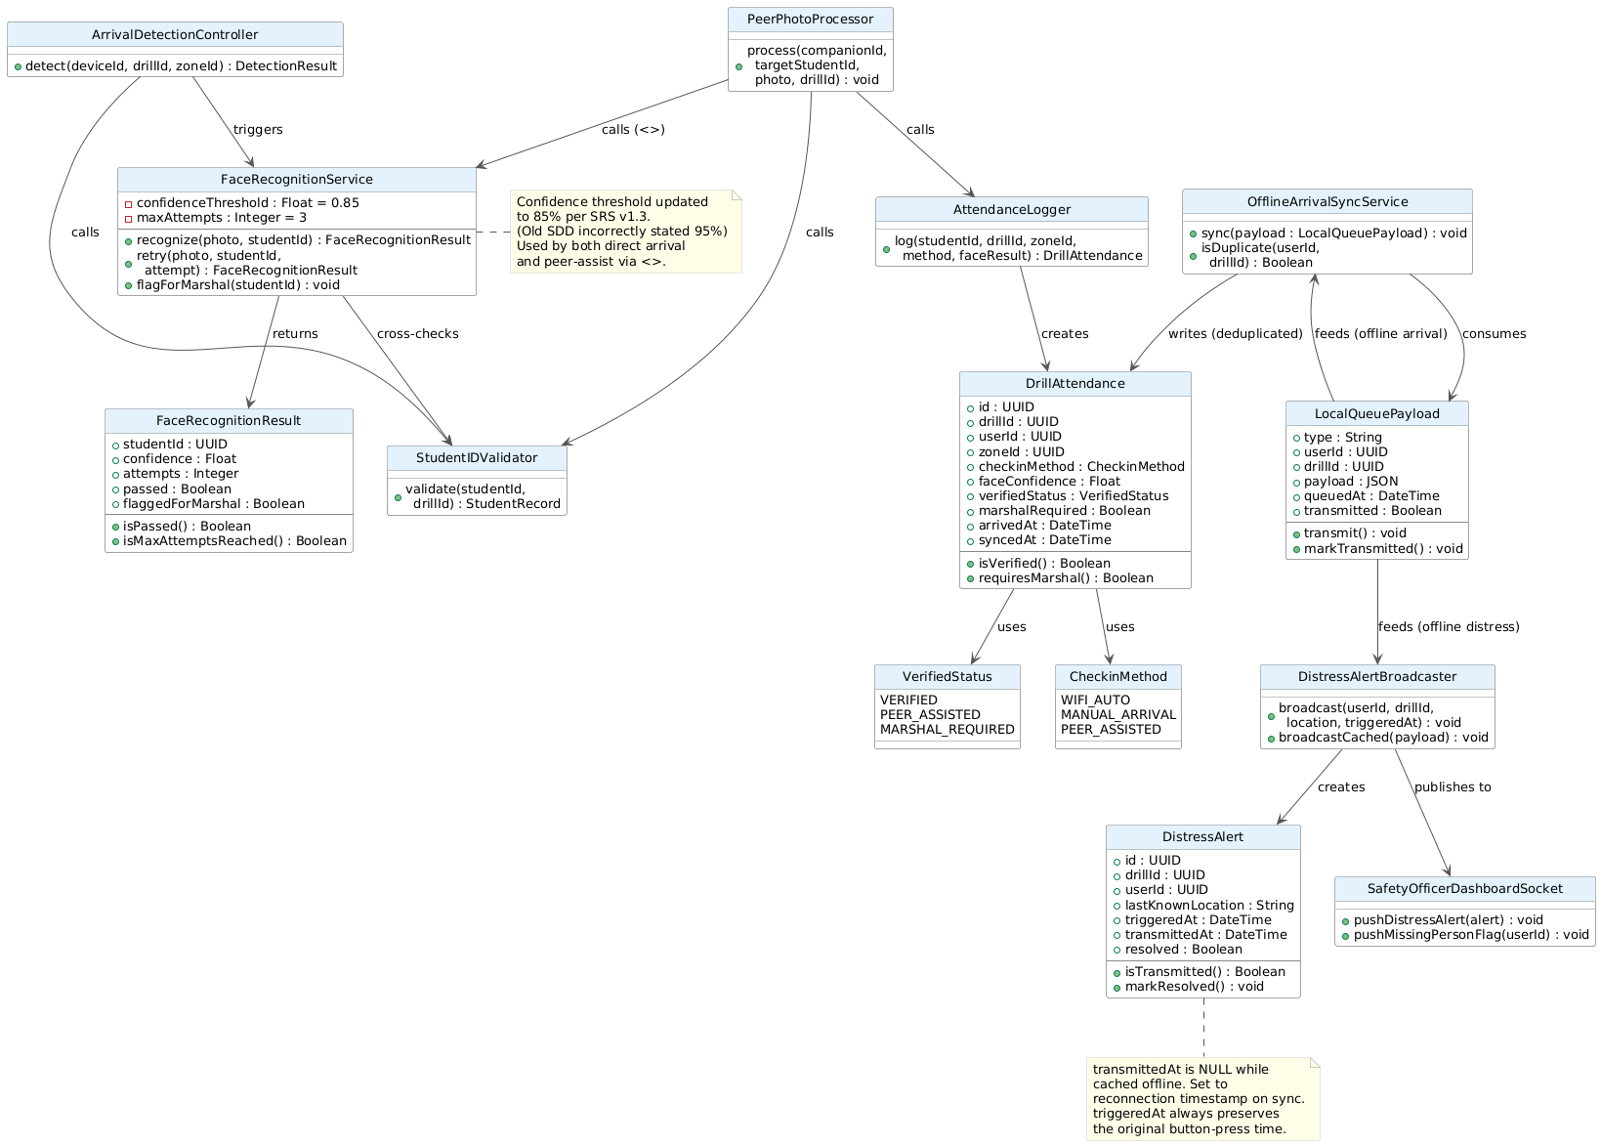

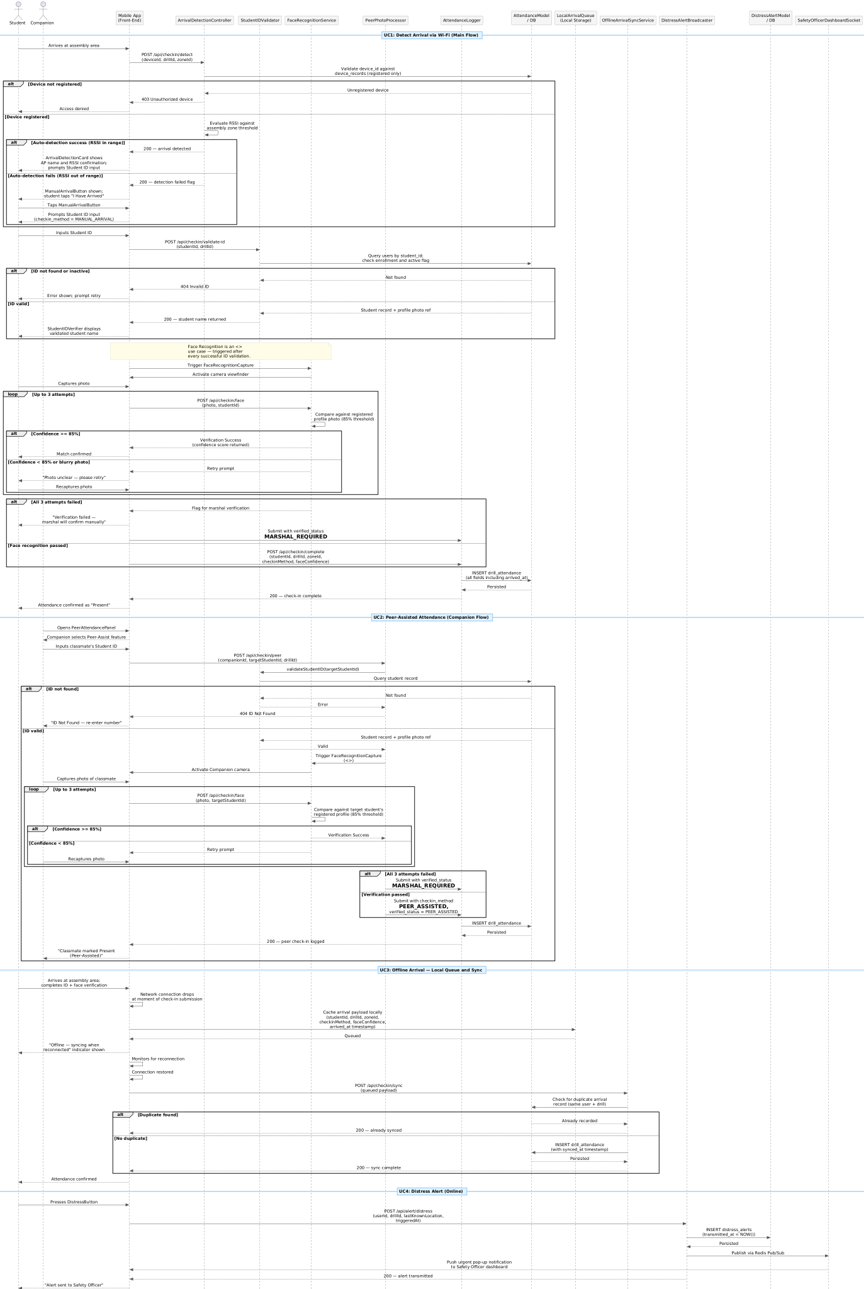

- Data Design
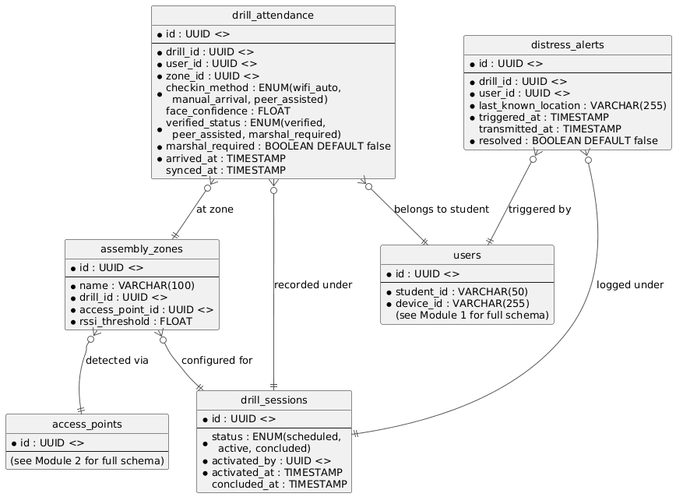

Module 5 Post-Drill Monitoring and Real-Time Reporting
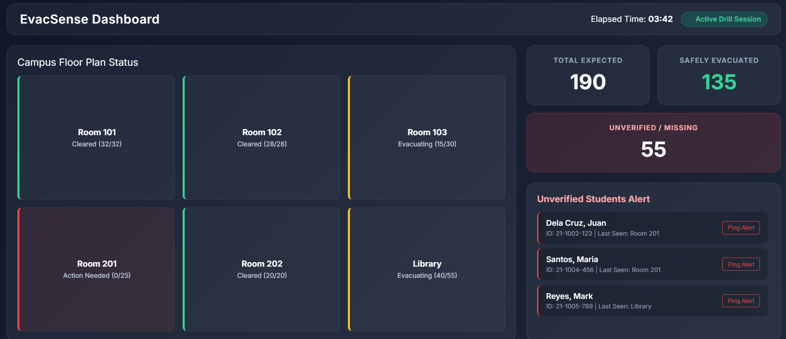

5.1 Live Drill Dashboard

- Front-end component(s)

Component Name | Description and Purpose | Type/Format
LiveDashboard | Main Drill Coordinator view; subscribes to the Coordinator WebSocket channel for real-time drill progress updates; distinct from the Safety Officer's SafetyOfficerDashboard in Module 4.2 — these are separate actors with separate dashboard interfaces | React.js Page
BuildingStatusPanel | Per-floor occupancy counts and clearance status with color-coded progress bars | React.js Component
AssemblyAreaPanel | Per-zone assigned vs. arrived counts with percentage and progress bar | React.js Component
DrillSummaryCard | Summary statistics showing total occupants, evacuated, not arrived, and progress | React.js Component
MissingStudentsList | Isolates unaccounted students for rapid manual triage by the coordinator | React.js Component

- Back-end component(s)
Component Name | Description and Purpose | Type/Format
DashboardController | GET /api/dashboard/:drillId; returns full drill snapshot | Node.js Controller
WebSocketServer | Socket.IO server; broadcasts headcount and status updates every 5 seconds or on event | Node.js/Socket.IO
DrillStateService | Maintains in-memory drill state; reconciles DB writes with live event stream | Node.js Service Module

- Object-Oriented Components
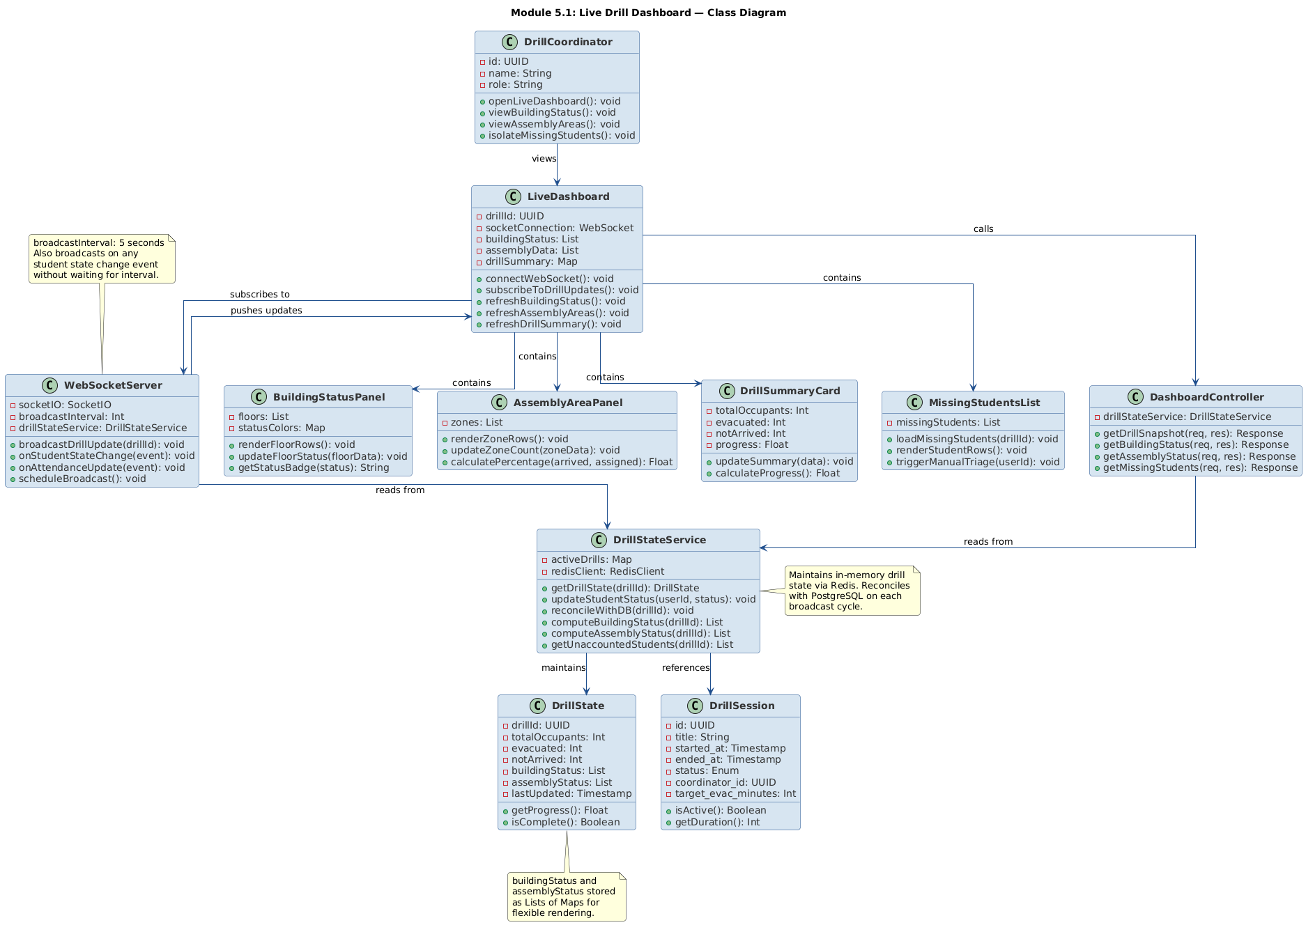
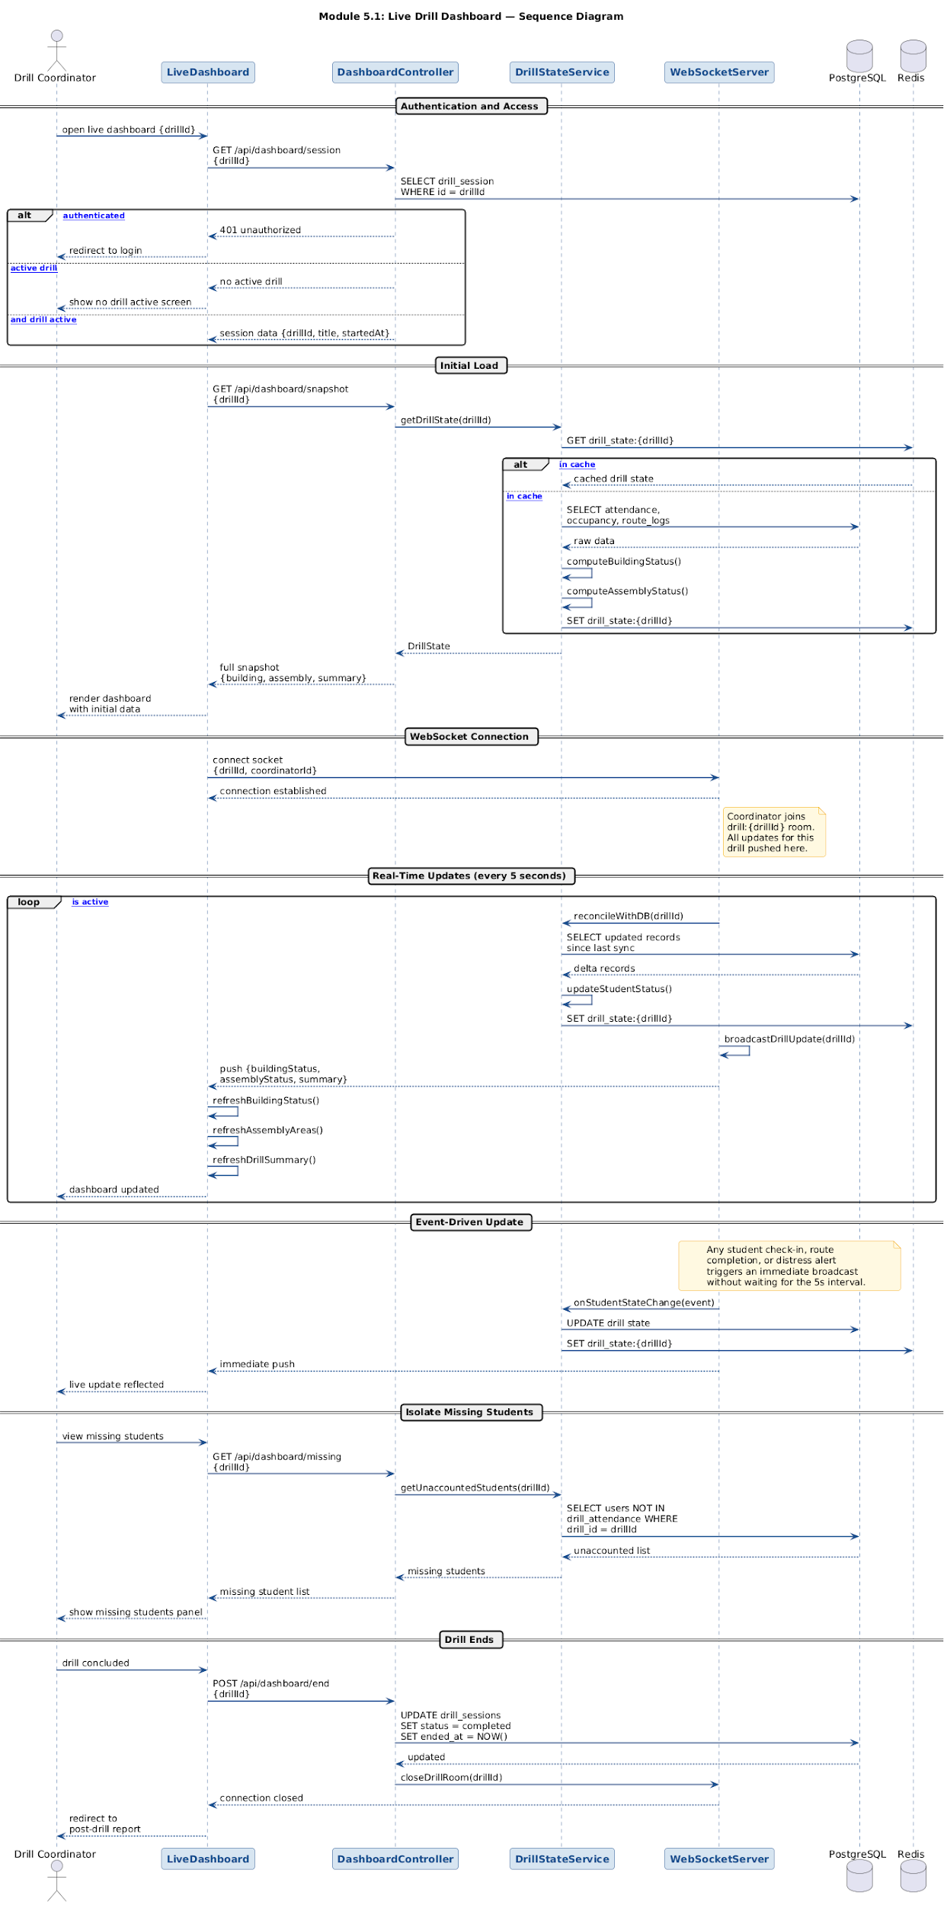
- Data Design
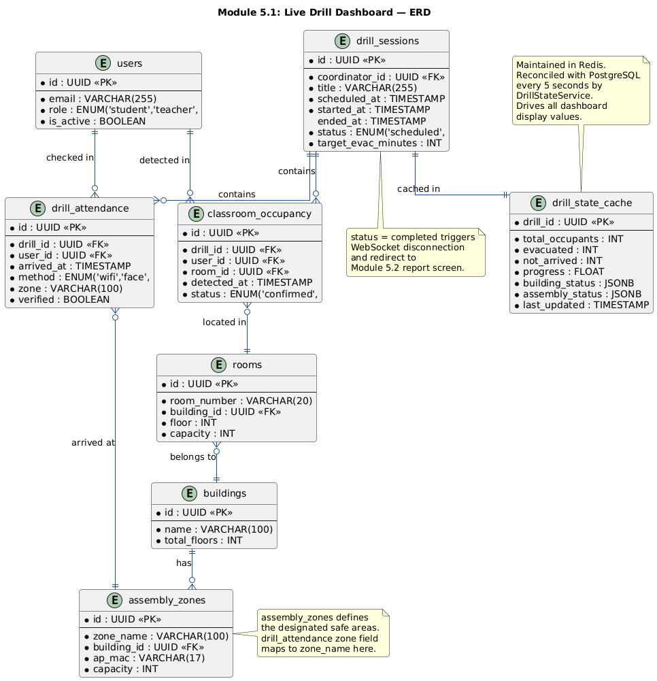

5.2 Post-Drill Report Generation
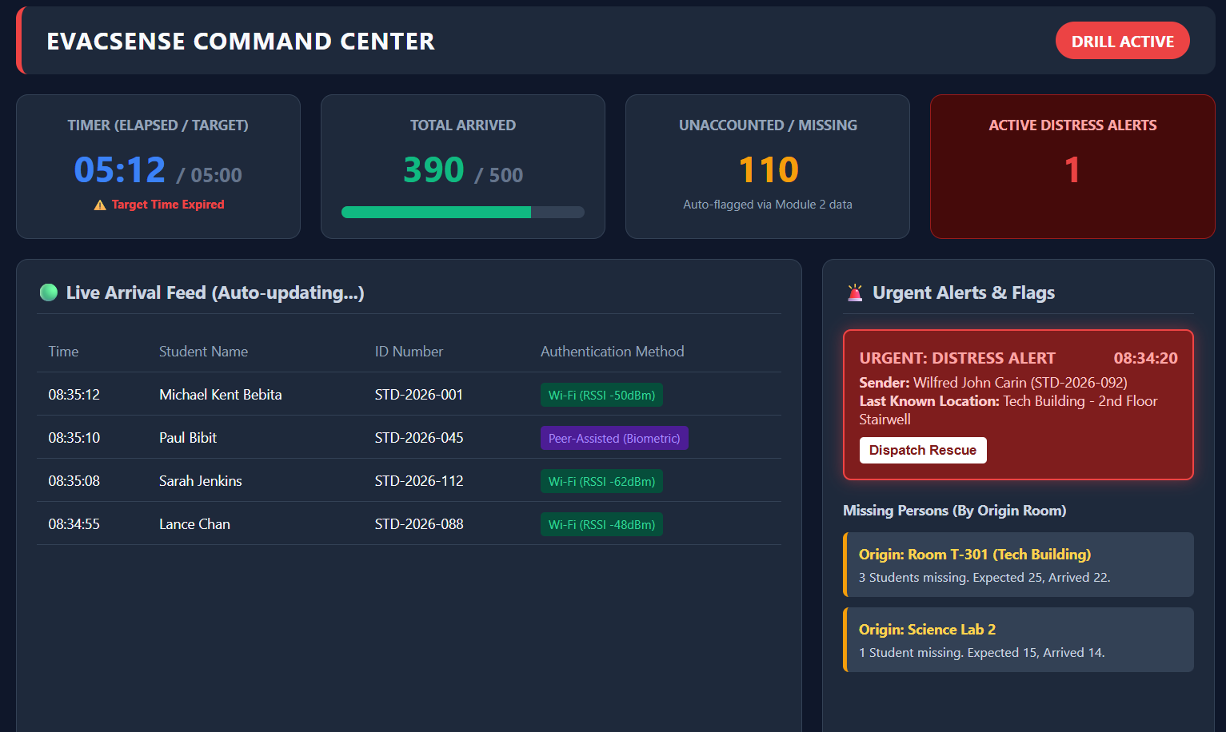
- Front-end component(s)

Component Name | Description and Purpose | Type/Format
ReportPreview | Displays compiled post-drill report in a readable format before export | React.js Component
FloorAnalysisTable | Per-floor table showing status (Cleared/Issues/Incomplete) and clear time | React.js Component
KeyMetricsPanel | Summary panel showing total occupants, evacuated, not checked in, and bottlenecks | React.js Component
ExportButtons | Triggers PDF or CSV download of the compiled report | React.js Component
- Back-end component(s)
Component Name | Description and Purpose | Type/Format
ReportController | Handles POST /api/reports/generate/:drillId; compiles the complete drill evaluation report by reading from the following cross-module tables: classroom_occupancy (Module 2 — pre-drill presence baseline and detection confidence), navigation_logs (Module 3 — per-student route origin, destination, computed_at, and delivered_at for bottleneck analysis), drill_attendance (Module 4.1 — arrival timestamps, check-in method, face confidence scores), missing_person_flags (Module 4.2 — unaccounted students list), distress_alerts (Module 4.2 — distress event log with triggered_at and transmitted_at); only executable when drill_sessions.status = concluded | Node.js Controller
PDFExporter | Uses PDFKit to produce formatted downloadable report with drill summary, floor analysis, and key metrics | Node.js Service Module
CSVExporter | Serializes attendance and timing data to CSV format with delimited matrix rows | Node.js Service Module

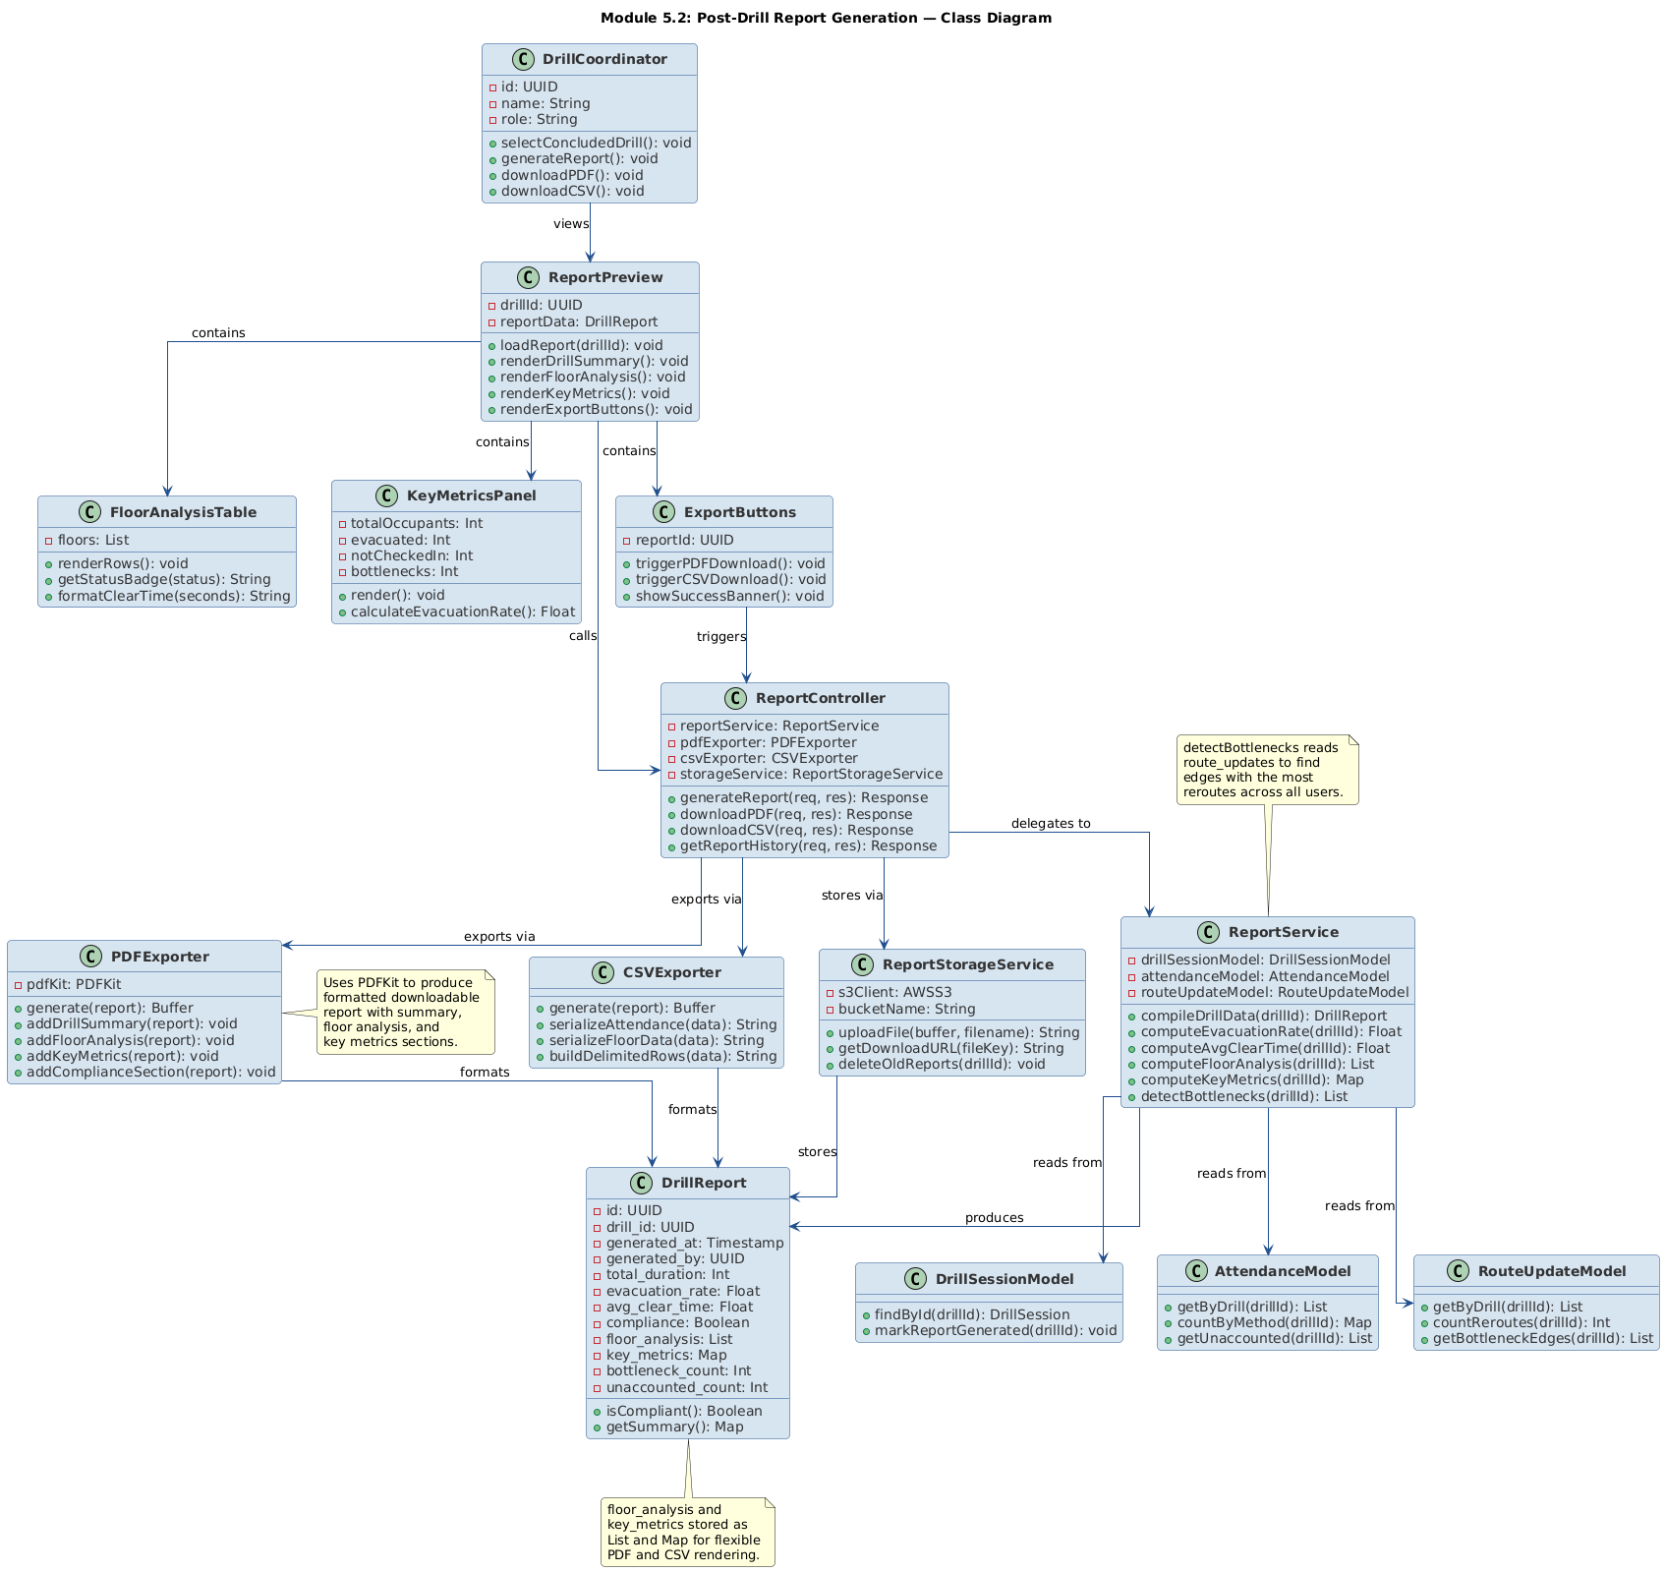
- Object-Oriented Components
